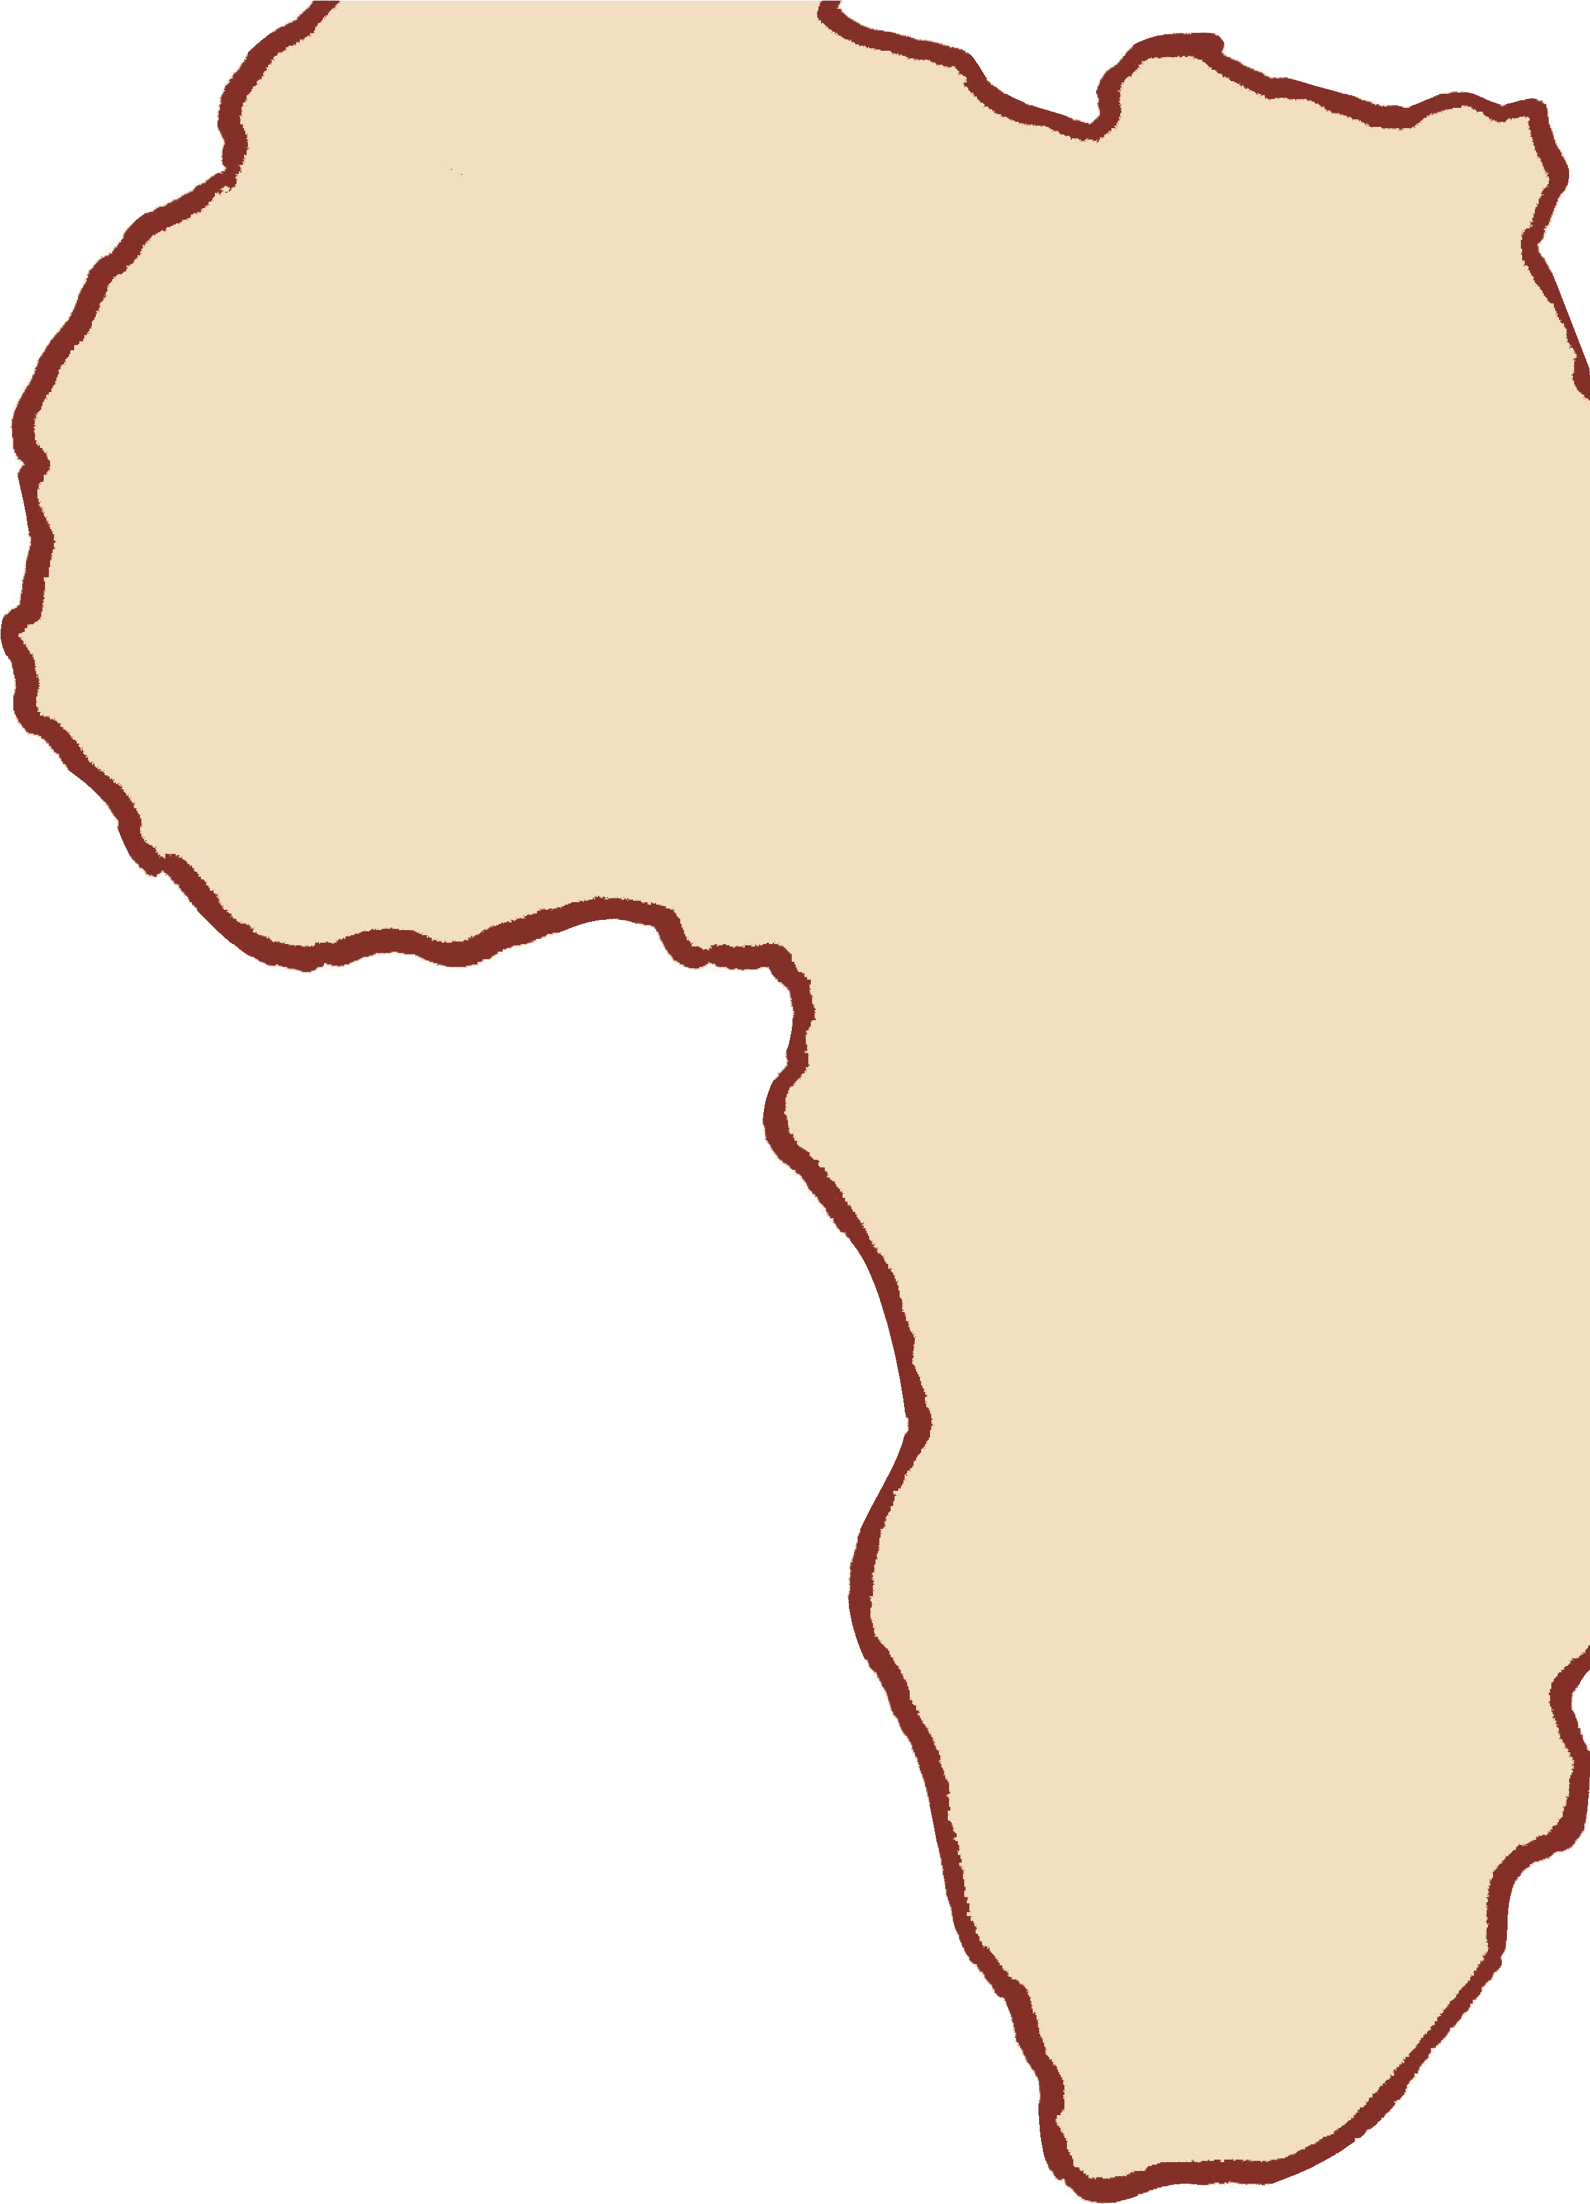
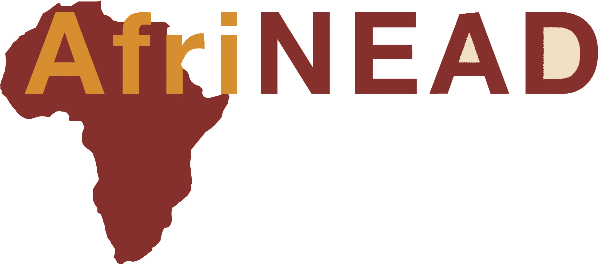
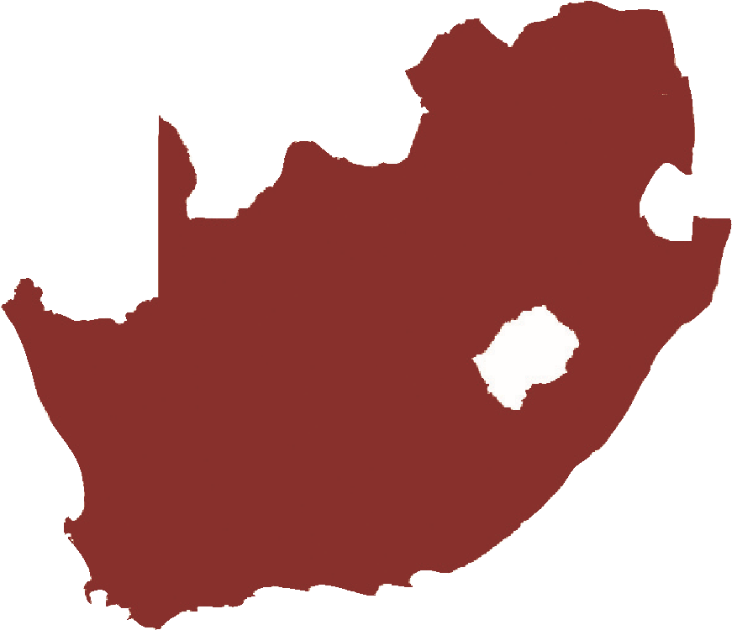
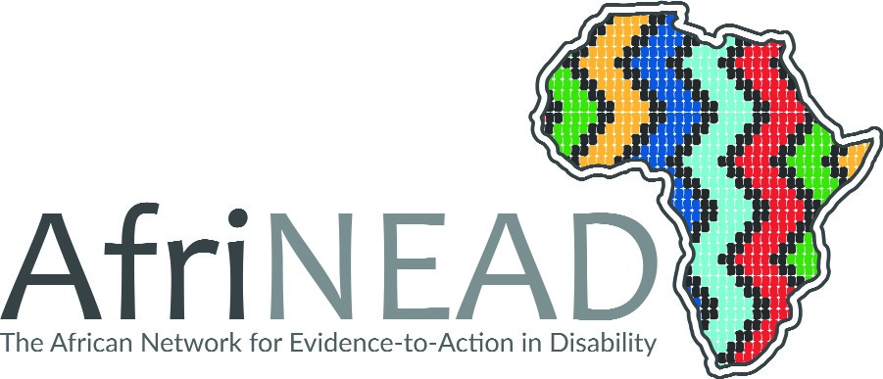
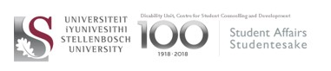
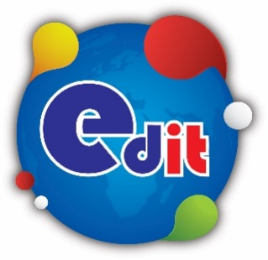
6
th
1
st-2nd December
2020
Virtually from Cape Town

YEAR OF DISABILITY/AfriNEAD Articles

CONFERENCE
The African Network for Evidence-to-Action in Disability

Hosted by:
Hosted by:

6th Annual AfriNEAD Conference

Theme: Disability unplugged-
Beyond Conventions and Charters:
What really matters to persons with disabilities in Africa.

1st – 2nd December 2020
Virtually from Cape Town, South Africa

A partnership with AfriNEAD and Edit Microsystems

SU's Rector and Vice-chancellor, Prof Wim de Villiers announced late last year that 2020 will be the university's Year for Persons with Disability. It will culminate in the sixth African Network for Evidence-to- Action in Disability (AfriNEAD) conference, a prestigious international network that will be hosted by SU from the 30 November to 3 December 2020. To honour this the Transformation Office and the Disability Unit, along with AfriNEAD, will publish monthly reflections or articles by persons with disabilities.
Table of Contents
Disability, as part of diversity, is moving at Maties 4
I have Cerebral Palsy. But I don't let it define me 6
Luigia Nicholas: Who am I? 7
My passion is teaching deaf children 9
To be a warrior is all about riding through the storms...orms… 11
What’s my superpower? I have Conversion Disorder. Not 'convulsion', CONVERSION. The hidden disability. 13
Seminar explores SA Sign Language interpreting in higher education 15
Special people serving the students’ special needs 18
AfriNEAD addressing lack of research about disability in Africa 21

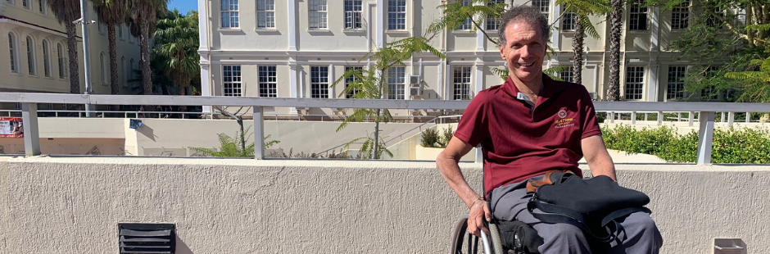

Disability, as part of diversity, is moving at Maties
Author: Transformation Office | Disability Unit | AfriNEAD | Wentzel Barnard
Published: 25/02/2020
​SU's Rector and Vice-chancellor, Prof Wim de Villiers announced late last year that 2020 will be the university's Year for Persons with Disability. It will culminate in the sixth African Network for Evidence-to- Action in Disability (AfriNEAD) conference, a prestigious international network that will be hosted by SU from the 30 November to 3 December 2020. To honour this the Transformation Office and the Disability Unit, along with AfriNEAD, will publish monthly reflections or articles by persons with disabilities. Our first piece is written by Wentzel Barnard, an alumnus who studied at SU from 1987 until 1994, and who now works as a Sports Manager at Maties Sport...
February's heat, paired with the buzz of excite​​ment as first-years crisscross the streets of Stellenbosch, takes me back to when I first rolled* onto campus. Looking back, it is great to see how Stellenbosch University has evolved in terms of providing for the needs of persons with disabilities.
In my student days, I had to deal with a physical environment that did not cater for wheelchair users, with building designs dating back to the 1940s, 1950s and 1960s. Most buildings could only be accessed by means of steps outside, and also had stairs inside. As an introvert, I found this challenging. Luckily, though, some students did ask whether I needed assistance. I also recall Prof Piet du Plessis carrying me up the stairs to a first-floor classroom in the Schumann building in my honours year.
Central campus surfaces were neither level nor evenly paved, which was difficult for a wheelchair user, and often, the back entrances to buildings ironically provided the best wheelchair access. Today, improving access for those in wheelchairs and other disability groups is high on the priority list when building new or renovating existing buildings. In some instances, however, the access issue is more one of attitude. This came to a head at my graduation …
Narrowminded protocol nearly put a damper on my big day. The stairs leading up to the stage in the then DF Malan centre (now Coetzenburg centre) hall where graduates are capped are very narrow. When I asked whether the Registrar would be willing to come down and hand me my scroll at the bottom of the stairs, I was given the choice to either be carried up those narrow stairs or to receive my degree in absentia. I refused both options, which resulted in a standoff. After newspaper threats (thank you, Corne Rossouw) and with only 30 minutes to go before the graduation ceremony, it was finally decided that the Registrar would descend the stairs and give me my scroll. Everyone in attendance praised the University for its efforts to ensure that a student with a disability would remember his or her graduation for the right reasons. Today, this procedure forms part of accepted graduation protocol.
Efforts to promote, and sometimes fight for, disability access to campus facilities and services have grown from a small group of individuals, namely Annette Barnard, Corne Rossouw, Gretha Jacobs and Messrs Van Tonder and Maas, into an entire office. Led by Dr Marcia Lyner-Cleophas, the Disability Unit addresses the academic needs of students with disabilities. The student organisation Dis-Maties, in turn, is responsible for the social side of student life, while Maties ParaSport manages sporting activities for the differently-abled from club to Paralympic level.
*I am a wheelchair user with quadriplegia (or tetraplegia), meaning all four my limbs are mobility-impaired. I have no use of my legs, and limited upper-body strength.

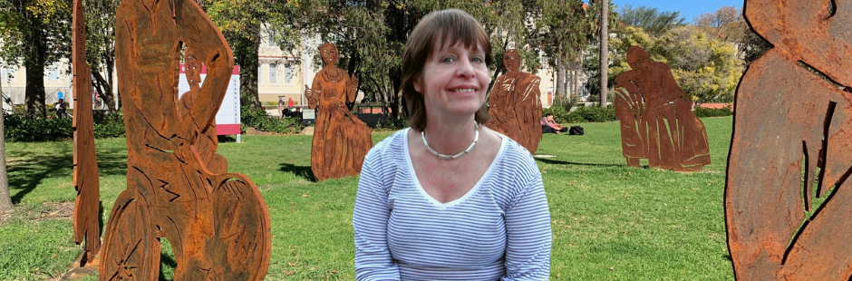

I have Cerebral Palsy. But I don't let it define me
Author: Transformation Office | Disability Unit | AfriNEAD | Hillary Lane​
Published: 30/03/2020
​​​​SU's Rector and Vice-chancellor, Prof Wim de Villiers announced late last year that 2020 will be the university's Year for Persons with Disability. It will culminate in the sixth African Network for Evidence-to- Action in Disability (AfriNEAD) conference, a prestigious international network that will be hosted by SU from the 30 November to 3 December 2020. To honour this the Transformation Office and the Disability Unit, along with AfriNEAD, will publish monthly reflections or articles by persons with disabilities. Our second piece is written by Hillary Lane​, the coordinator for AfriNEAD, a disability research evidence project that has been initiated in the Medicine and Health Sciences Faculty of the University of Stellenbosch within the Centre of Rehabilitation Studies.​
I have Cerebral Palsy. But I don't let it define me.
My greatest handicap has actually been my handwriting – I used a typewriter throughout my school career, starting off with a manual machine. It's not that I can't write, I need to support my left hand on my right hand to stop it from shaking. My teachers used to say that I had to learn to write because if I didn't, how was I going to sign cheques one day?
This is what prevented me from going to university, as we did not have laptops then. I would have loved to have studied to become an occupational therapist – my teachers thought that I would have made a good librarian – really? The interesting thing is that I have worked most of my life when I was not rearing my two children, and not once have I applied for a job. I was always asked to work: from running a restaurant, being a CEO, managing a second-hand clothes shop manned by people in wheelchairs, and so many other positions.
More than anything though, I would have loved to have said that I had been at university. Well I can say that I studied at Oxford – that is where I was at boarding school, but when you say that you were at Oxford everyone just assumes you studied at the university.
Now I can say that I am at Stellenbosch University and have been there for seven years. I am the coordinator for AfriNEAD, a project started by the head of the Centre for Disabilities and Rehabilitation Studies, Prof Gubela Mji. This has been the most wonderful time of my life. Little did I know what an amazing journey this would turn out to be when she phoned and asked me to come and see her!
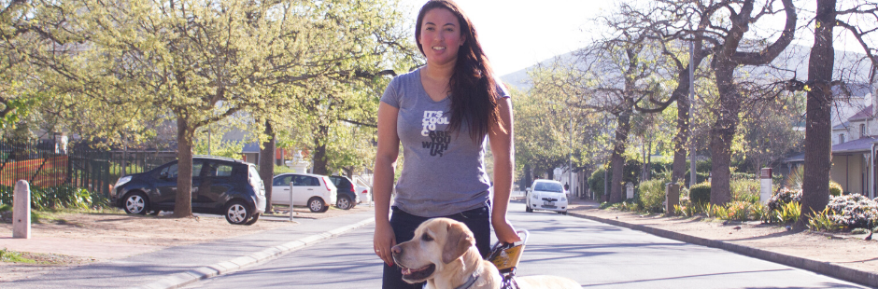

Luigia Nicholas: Who am I?
Author: Transformation Office | Disability Unit | AfriNEAD | Luigia Nicholas
Published: 05/05/2020
​​​SU's Rector and Vice-chancellor, Prof Wim de Villiers announced late last year that 2020 will be the university's Year for Persons with Disability. It will culminate in the sixth African Network for Evidence-to- Action in Disability (AfriNEAD) conference, a prestigious international network that will be hosted by SU from the 30 November to 3 December 2020. To honour this the Transformation Office and the Disability Unit, along with AfriNEAD, will publish monthly reflections or articles by persons with disabilities. Our third piece is written by Luigia Nicholas who is currently studying towards a Postgraduate Diploma​​ in Tax Law; she is also the SRC's Special Needs Manager.

Growing up as the oldest of three children, I have always felt the pressure of being the most responsible child and trying to set a good example for my younger siblings. I have struggled all my life with poor eyesight. As a youngling, the teachers would tell my parents that I had lazy eyes or needed to use glasses, but these would never help. I had to struggle to get through my primary school career by asking the teachers and my classmates to assist me, among other thing by copying work out of their textbooks, as I could not see the board clearly. This left me feeling useless, as if there was something wrong with me.
I was diagnosed with my first eyesight condition, S Margaret's disease, only in Grade 8, at the age of 14. At the beginning of my high school career in 2014, I was diagnosed with a second eye condition, namely uveitis. Having discovering what was wrong with me, I could work around how to make my life easier and what to do to help my schooling. Because I went to a mainstream private school and not Pioneer School, I had to help the school to adjust to my needs. I taught them how to assist me with my eyesight condition so that I could do the best in my schooling. During this time, I realised I had a talent for educating people on how to assist those that are different.
I had lived 12 years of schooling and 3 years of university without most people knowing that I had an eyesight condition and being a 'normal' student, but when I received Haiku (my guide dog) everything changed. People's attitudes towards me changed and everyday activities became harder to do. The first time I took Haiku shopping with me was a completely new situation. It felt as if the entire store was staring at me, which made me feel insecure and discouraged me from going to the store again. I was forced to make a decision – either feel sorry for myself and accept life as it is, or fight to make a difference.
After coming to university, I began interacting with other differently-abled students. That gave me a sense of belonging and I soon realised that I was not the only person struggling with issues of acceptance into a society that did not adapt to my needs. Interactions through society work and social, as well as university work have shown me that students need a space to feel heard. Being involved in a disability awareness in society has demonstrated that students need a space where they can vent and engage with others in their everyday life struggles. This needs to be a space where they can speak to someone who shares their experience and can give advice and guidance on how to deal with certain conflicts.
However, students do not want to be recognised only for their disabilities, but also for their other abilities. I decided to change my narrative of being recognised only by my disability by getting involved with societies that are not focused on disability awareness. I joined societies that reflect my other passions. I also have an interest in film, church societies, arts and crafts, and board games.
I have also worked to better my leadership skills through participation in short courses and leadership positions. This helped me grow as a person and become more comfortable with my other interests. I stepped outside my comfort zone and in doing so, indirectly started educating others and making them more aware of accessibility issues they might have and how they could create a more inclusive environment for people with disabilities.

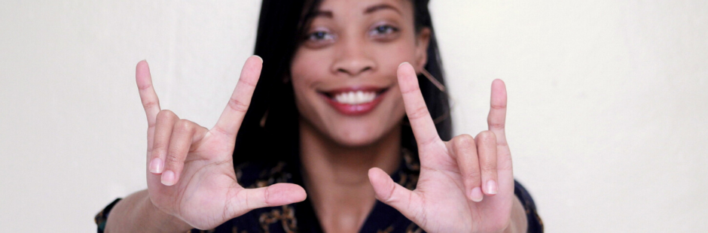

My passion is teaching deaf children
Author: Transformation Office | Disability Unit | AfriNEAD| Ilze Aaron
Published: 08/06/2020
​​​​​SU's Rector and Vice-chancellor, Prof Wim de Villiers announced late last year that 2020 will be the university's Year for Persons with Disability. It will culminate in the sixth African Network for Evidence-to-Action in Disability (AfriNEAD) conference, a prestigious international network that will be hosted by SU from the 30 November to 3 December 2020. To honour this the Transformation Office and the Disability Unit, along with AfriNEAD, will publish monthly reflections or articles by persons with disabilities. Our fourth piece is written by Ilze Aaron, a student at Stellenbosch University, who is studying towards a BEd in the Faculty of Education.

I am Ilze Aaron, and I am 22 years old. I come from Paarl. When I was about 9 or 10 years old, my aunt noticed that my speech was different and at her suggestion, my mom took me to Tygerberg Hospital to have the necessary hearing tests done. It was confirmed that I had hearing loss. Two days after the news, my mom went back to the doctor and asked him what she could do to help me. He suggested that I wore hearing aids to improve what hearing I had left.
The moment that I put the hearing aids on, I was amazed that I could hear everything around me, the wind blowing and the birds singing. It was a big challenge and a huge adjustment for me, but without my mom, I would have lost all hearing and speech and I am forever grateful to her. She spent hours teaching me how to pronounce words until I got it right. She tried to make my life as 'normal' as possible.
I started my school years at Nederburg Primary School and then attended Labori High School in Paarl. I stayed until Grade 8 where my classes consisted of about 30 learners. The teacher made me sit in the front row in class so that I could try to lipread her, but I could never participate – I could not follow the class.
We then found out about De la Bat School for the Deaf, and in 2012 I moved schools. The new challenge was that I had no knowledge of sign language. I had to take extra classes after school to learn South African Sign Language (SASL) for three months so that I could communicate with my fellow learners. Fortunately, I got the hang of it fairly quickly. Towards the end of my schooling, I even started helping out as interpreter between our teacher and my fellow learners in class, because the teacher could not use SASL fluently enough for them to understand her.
After matric I worked as a teacher's assistant at Dominican Wittebome School for the Deaf where I learned a great deal about being a teacher for deaf children. One day out of the blue, I was contacted by De la Bat School to ask whether I would be interested in applying to study at Stellenbosch University. Initially I was unsure, but after giving it some thought, I realised that I had to grab this opportunity and I sent in my application. I did not tell anyone that I had applied, and for a few months I did not even check my emails thoroughly. Then I found an old unread email from Stellenbosch University congratulating me on being accepted to the BEd 2017 programme! I could not believe what I was reading! I could not wait to tell my family about this new reality waiting for me.
In preparation of becoming a Matie, I had to attend a meeting during which I had to indicate my specific communication needs in order to attend classes. This was a big new world for me, and the adjustment was going to be huge! At this meeting, I was blessed to meet my friend Imran Bodalaji, another deaf student who would also be studying BEd with me, and suddenly I did not feel alone anymore. At this meeting, I also experienced my first encounter with an SASL interpreter and was pleasantly surprised.
Our first day of class was difficult for Imran and me. We got lost all the time and had no clue where to be for classes. We were also unsure of how we would communicate with the other students in our classes. Our thanks go to the Disability Unit and the Language Centre for providing us with SASL interpreters who made it easy for us to bridge the communication divide. The interpreters were there from the start, making sure that we had access to lectures and learning material, and knowing that I was being included made me feel good. Moving from a deaf environment to a world where everyone could hear certainly was a big adjustment.
Some students took the initiative and used their phones or pen and paper to communicate with us while others came up to us after class, asking where they could learn SASL, and I was pleased to tell them that an SASL module was available in the Faculty of Education. They were always surprised to hear my voice when I spoke to them. Imran and I also worked as tutors for the SASL module for a while, and when a stranger greeted me in my own language outside of class, it made me feel so good. If people could not sign yet, they stopped us and asked us how to sign a greeting or something else.
My passion is teaching deaf children so that they can receive an education in their own language from another deaf person and being role model for them. I want to inspire them and make sure that they know they can fulfil their dreams, no matter who or what they are. I decided that I would rise above my circumstances and that no matter what, I would bring about change in my deaf community. I cannot wait to graduate just to prove that deaf people also have dreams and that we can achieve anything that we set our minds to.

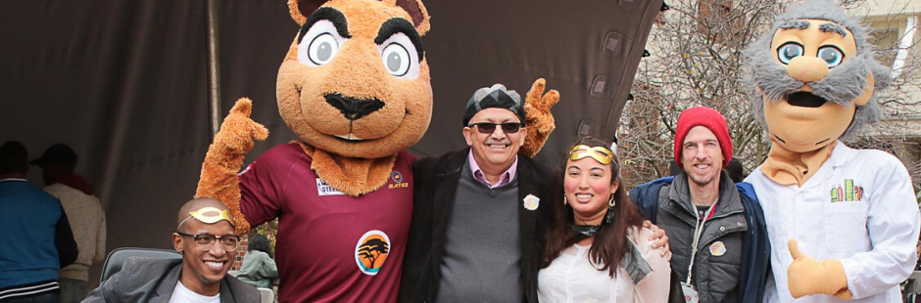

To be a warrior is all about riding through the storms...orms…
Author: Transformation Office | Disability Unit | AfriNEAD| Ulf-Dieter Koepp
Published: 21/07/2020
SU's Rector and Vice-chancellor, Prof Wim de Villiers announced late last year that 2020 will be the university's Year for Persons with Disability. It will culminate in the sixth African Network for Evidence-to- Action in Disability (AfriNEAD) conference, a prestigious international network that will be hosted by SU from the 30 November to 3 December 2020. To honour this the Transformation Office and the Disability Unit, along with AfriNEAD, will publish monthly reflections or articles by persons with disabilities. Our fifth piece is written by Ulf-Dieter Koepp, a junior technical officer​, in the Faculty of Arts and Social Sciences.

​
​I am Ulf-Dieter Koepp from Windhoek. I was born deaf with a cleft palate. My deafness is a result of my mother having had German measles during her pregnancy. My mother taught me lipreading when I was a very little boy, and my schooling took place at Dominican Grimley School for the Deaf in Hout Bay from about 1982 to 1998.
I have now been working at the Faculty of Arts and Social Sciences at Stellenbosch University (SU) for over three years as a junior technical officer. Before SU, I used to work on testing various applications by using Android Studio and MIT App Inventor (online). One of my many ideas was the one on Ava (https://www.ava.me/). I also assist the Humarga Helpdesk by monitoring personal computers and printers and stocking up paper reams. I have about five years of experience as a printer technician with various companies.
I was at a crossroads at the beginning of 2017, one year after the start of my employment at SU and my mother's sudden death in June 2016. I had been used to being deaf for 41 years, but this was not the case with the 'Big C'. At that crossroads, that 'C', nasopharyngeal carcinoma, held a gun to my head.
How did this cruel thief sneak into my body? Why had I not noticed this earlier? The fact was that I had booked air tickets to Namibia for a three-week vacation in November 2016, not knowing that I would be heading into another unknown direction. I had asked the ear, nose and throat surgeon whether I qualified for a cochlear implantation as a new candidate. Boom – the radiologist discovered a mass lesion deep in my left nasopharynx section after CT and MRI scans had been completed. It was presumed to be Stage 1 – so early! But within two weeks, it had grown to Stage 2. I had no symptoms such as swollen lymph nodes, swollen neck, severe headaches or persistent sinus issues.
How exactly did I manage to pull through? I used to think that SU was anything but a normal employer when it came to annual leave and sick leave, but I was shocked to see how it had structured sick leave in a way that went beyond my logic. I know that with any company, when illness struck an employee, the standard procedure was to grant that employee a limited grace period. However, when I looked at the way in which sick leave was structured, I thought, “Am I seeing something that is unique?" When an employee is extremely ill for a long time, SU has something called 'disability cover', which is extremely helpful in covering the loss of income. Indeed, SU is an upfront-unified-unbeatable, one-of-a-kind employer that is really committed to its students and staff, also a staff member with a disability!
Yes, I came out as a cancer warrior in complete remission in August 2017 and still am to date. To be a warrior is all about riding through the storms and finding the sunshine one day. Everything before my official diagnosis and during the treatments stripped me as if I were an onion being peeled away. Never had I thought that my theological studies at Cape Theological Seminary (Pentecostal-Charismatic Bible College, 1999 to 2002) would one day be put to the test when the 'Big C' interrupted my life like a Goliath.
Did I manage to obtain the implant? Unfortunately, not yet, but I am aware that Discovery Health does fund this type of operation from benefits. Both my oncologist and ear, nose and throat surgeon wonder whether I am still keen on cochlear implantation. The truth is that it does not always suit everyone.

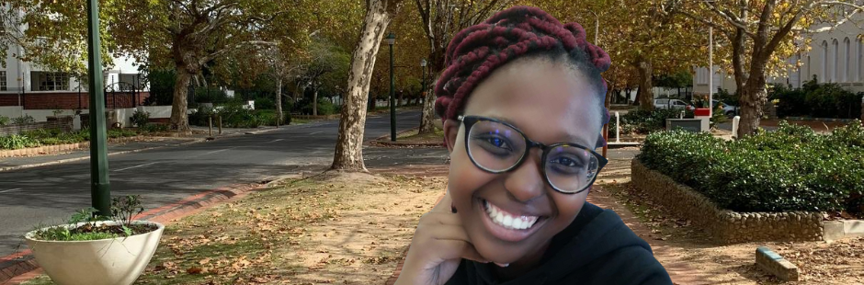

What’s my superpower? I have Conversion Disorder. Not 'convulsion', CONVERSION. The hidden disability.
Author: Transformation Office | Disability Unit | AfriNEAD | Lathi Msi
Published: 26/08/2020
​ SU's Rector and Vice-chancellor, Prof Wim de Villiers announced late last year that 2020 will be the university's Year for Persons with Disability. It will culminate in the sixth African Network for Evidence-to- Action in Disability (AfriNEAD) conference, a prestigious international network that will be hosted by SU from the 30 November to 3 December 2020. To honour this the Transformation Office and the Disability Unit, along with AfriNEAD, will publish monthly reflections or articles by persons with disabilities. Our sixth piece was written by Lathi Msi, a BA ​Humanities student.

“Ooh, is that a group of potentially eligible bachelors? Now's the perfect time to cause some chaos."
“Is this that class you failed last year and are desperate to pass this year? There hasn't been a more suitable hour for a little chaos!"
“You poor thing, are you trying to walk to another building in 10 minutes? It's a pity; I'm seeing the perfect opportunity for some chaos."

That's my body telling me it's under a bit of pressure. The chaos reaction is a full-blown, limb-twitching, head-banging, teeth-chattering seizure. Yes, I occasionally have grand mal seizures that can last anything from a minute to half an hour.

What's my superpower? I have Conversion Disorder. Not “convulsion", CONVERSION. The hidden disability. Hidden because I look perfectly healthy until I start vibrating and my eyes start rolling. There is no known cure for it, but it can become a thing of the past with a few years of therapy. But nobody knows how many years or with which specialising therapist or how long you'll spend with every specialising therapist until something somewhere clicks. But I must say, in my case, although therapy hasn't made my symptoms disappear, it sure has lessened them. Psychology working hand in hand with psychiatry and lots of patience.

I was diagnosed with Conversion Disorder in 2016, in my final year in high school. In 2017 I was introduced to an entirely new environment: stairs to reach my bedroom, paced 10-minute walks between buildings to get to lectures and having half my high school's amount of students in one lecture hall. It was exciting. I loved the buzz. My body didn't quite agree, though.

I spent 2017 having lectures cut short because of the chaos caused by a seizure during a lecture. I was carried up flights of stairs, made friends with the sisters at Campus Health and soon enough was known as the person to be cautious around in my faculty and residence. Never too much excitement. Never too much pressure. It was unreal. It was boring.

This was all before I was introduced to the University's Disability Unit. The superheroes. I only requested a way to have my classes recorded for me, instead of me walking all the way, only to disrupt a lecture. The Disability Unit quickly came to my aid, arranged top-quality equipment for my studies and for the recordings to be made and covered all the costs. They immediately contacted all my lecturers and made all the arrangements for me to have an assistant that walked with me to all my lecturers to explain. Getting podcasts from some lecturers was like pulling teeth from a tiger.

That's how I can say the Covid-19 lockdown rescued me. Along with the support of the Disability Unit, online learning made my studying much easier. It forced lecturers to post all the details online on time, the assessments were done online and whenever I had a seizure while working, I could rest and work at a time that suited me.

​



Seminar explores SA Sign Language interpreting in higher education
Author: Disability Unit | AfriNEAD | SU Language Centre
Published: 29/10/2020
Since September is International Deaf Awareness Month, it was apt for the Stellenbosch University (SU) Disability Unit and the SU Language Centre to collaborate to host the 2020 South African Sign Language Interpreters' Code of Ethics seminar from 7 to 9 September. The seminar theme, “Triangulation of the Code of Conduct for SA Sign Language interpreters in higher education," drew perspectives from Deaf students and lecturers, as well as South African Sign Language (SASL) interpreters, and highlighted the importance of a code of ethics for interpreters working in higher education. The articles are part of the 2020 Year of Disability series.
Currently, there are no official or consistent guidelines for Sign Language interpreters working in the post-school education context in South Africa. A working document by the Higher and Further Education Disability Services (HEDSA), initiated by the Deaf Federation of South Africa (DeafSA), contains a code of ethics for interpreters and guides the work and employment of SASL interpreters in South Africa. However, this document is not used consistently in the post-school education and training (PSET) sector, and the code of ethics does not focus specifically on educational interpreting in higher education.
In 2019, the University of Cape Town jumpstarted the discussion around a code of ethics for SASL interpreters working in the PSET sector in South Africa with the very first SASL Interpreters' Code of Ethics seminar. This year, the discussion moved to SU, and what better way to give prominence to the fact that SU declared 2020 as the institution's Year of Disability?
Owing to the COVID-19 pandemic, the seminar was hosted online over three consecutive days. The move online extended the seminar's reach, allowing discussions of the myriad of challenges faced by students who use SASL interpreting in university settings, educational interpreters, disability units and Deaf lecturers. One of the key seminar questions was: With only a generic code, how do we guide the process of interpreting and receiving interpreting in the specific post-school environment, and how do we protect SASL interpreters and users of SASL interpreting alike?
Natasha Parkins-Maliko, a PhD candidate and lecturer in SASL interpreting at Wits University, opened the floor by speaking about the importance of being reflective language practitioners. She felt strongly that SASL interpreters must be specialists in one or two spoken languages and be highly conversant in academic Sign Language to interpret effectively at this level of study, to do justice to the students they serve. However, can interpreters work effectively in the post-school context with no formal university training themselves? The conundrum is that very often SASL interpreters may have gained their expertise in interpreting outside the higher education context, and so it is counter-intuitive to make a university qualification in interpreting the benchmark for quality service in the current South African context. At the same time, it is important that interpreters understand the academic language used in higher education contexts, and this understanding can only come from studying at university. The answer could lie in developing a recognition of prior learning (RPL) programme for SASL interpreters that recognises prior experience for those enrolling for a qualification in interpreting, as is the case at Wits University.
Besides encouraging interpreters to develop their interpreting skills by enrolling for a higher qualification in interpreting, the seminar once again emphasised the need for SASL interpreters to do research to expand their terminology in academic disciplines in the field of higher education.
The question of the accountability of SASL interpreters employed in post-school and university environments drew much debate. Are SASL interpreters accountable to the students for whom they interpret, or does accountability lie with the interpreters' line manager or department, or with the institution, as SASL interpreters are also employees of this institution? As important was the positioning of SASL interpreters regarding their personhood, their students, the lecturers and the institution. This resulted in further lively debates.
Deaf university students Imran Bodalaji and Qobo Ningiza shared their experiences as Deaf students and users of SASL interpreters in classroom and meeting contexts. Their presentations and the ensuing discussions allowed participants to consider the role of SASL interpreters from the perspective of a student – the first stakeholder in the triangulation process. Like many other students, Imran and Qobo had to adjust to the academic language used in higher education. They both encountered terminology during their studies that they had never seen before: it was either new to them in SASL or had to be developed. This shows that SASL interpreters have a critical role to play in the classroom. In this triangulation between the student, the lecturer and the interpreter, what is the latter's role? Should the interpreter correct the information given by the lecturer when the lecturer is clearly wrong? How does the interpreter communicate that they are not sure of the sign for terminology used in the classroom? Imran and Qobo also shared some thoughts on the isolation that students who are Deaf feel in a hearing world.
SASL lecturer Susan Njeyiyana, who is Deaf and uses SASL as a primary mode of communication herself, shared her experiences on the third day. Hailing from the SU Department of Linguistics, she related how a Deaf lecturer experiences the hearing world of classrooms and staff rooms. She did, for example, not have access to an interpreter for impromptu meetings with individual students or when she needed to communicate with colleagues. A common shortcoming she recognised in SASL interpreters is the quality of interpreting from SASL to voice, which has implications for how she, as a Deaf individual, is perceived. Her advice for interpreters is to try consecutive interpreting; the interpreter should first understand the meaning before they start voicing. Susan's presentation also led to discussions around cultural appropriation for personal gain, as well as terminology development and quality assurance.
SASL interpreter Marsanne Neethling shared her experiences during the final session of the seminar. Marsanne is an interpreter employed by the Interpreting Service at the SU Language Centre. She quoted Maartje de Meulder, saying that often Deaf academics play “interpreter roulette" – as a Deaf individual, you never know what the calibre of the interpreter you end up with will be. The same is true in the wider post-school context. How do we ensure accessible communication for Deaf students? Marsanne spoke about the need for interpreters to have a thorough understanding of the cultural and social background of both the source language and target language of the users in the classroom – something that is vital for mediating an understanding of the lectures. To achieve this, SASL interpreters sometimes may need to step outside the role traditionally assigned to interpreters. In her research, Odette Swift recorded a student saying in this regard, “Is it weird to say she's like a friend because she cares about whether or not we understand the work?" SASL interpreters do not make signs only – they make meaning.
The 2020 SA Sign Language Interpreters' Code of Ethics seminar provided a platform for Deaf students and lecturers and SASL interpreters who share a space in higher education environments to speak their minds, voice their needs and together build bridges that will ensure successful studies for students and growth for SASL interpreters – as collaborators. The seminar highlighted the need for an interpreting code of ethics in higher education that could guide stakeholders in the future.
A working group has been established to develop a document that might serve as a guideline or code of ethics for interpreters working in higher education. The group consists of volunteers from all higher education institutions with experience in SASL interpreting, and includes members of the Deaf community.
The 2021 SA Sign Language Interpreters' Code of Ethics seminar will be held at the University of KwaZulu-Natal.​



Special people serving the students’ special needs
Author: Heather Osborn and the Neurodiversity Centre, Franschhoek | Disability Unit | AfriNEAD
Published: 27/11/2020
​​Special people serving the students’ special needs​
The administration and support units of Stellenbosch University (SU) are known for their professionalism, efficiency, and service excellence. However, to myself and my dear daughters with neurodevelopmental needs, one unit stands out above the rest. This is not only due to the very nature of that unit, but also to the staff members’ compassion, dedication, and willingness to go the extra mile in assisting students – such as my children – with special needs as well as their families. That unit is the Disability Unit, led by Dr Marcia Lyner-Cleophas.
Both my daughters are on the autism spectrum.​
Autism with its various manifestations is often very difficult to understand and support – not only because one cannot ‘see’ autism, but also because the needs of each person on the spectrum are different and unique to that individual. Also, so much real empathy is needed to understand the experiences of young people with autism conditions. What has been abundantly clear to us as parents is that our daughters have constantly required certain concessions and specific types of support to ensure that they reach their full potential and can actually participate in our world – the world of people without autism.
The transition from high school to university is somewhat frightening for all parents and children because the children become more independent and take the leap into an unfamiliar environment. This transition was especially difficult and nerve-racking for my two daughters and me, as I knew that, because of the incredible impacts of their autism, the odds that they would succeed in their studies without the right support, regardless of their levels of intelligence, were low.
On my arrival at the Disability Unit for the first time in 2016, I was overwhelmed by the warmth, respect, and professional care we were met with. We met with Dr Lyner-Cleophas of the Disability Unit to explain my eldest daughter’s needs and the assistance she would require during her time at SU. She was attentive and highly receptive to understanding my daughter’s needs and experience of learning, and asked questions to ensure that she could help my daughter in every way possible.
Prior to the start of the academic year a meeting was scheduled for my eldest, my husband and me with Dr Lyner-Cleophas, Prof Slattery (the head of the Department of Statistics and Actuarial Science), and the course convener to discuss and determine what kind of special assistance my daughter would need to support her in obtaining her degree. ​
As this was done before classes had even started, my eldest daughter was fully prepared for her first year at university, thanks to the Disability Unit. She has now been studying for three-and-a-half years, after taking 2019 off to obtain additional Actuarial Society credits, and is still receiving amazing support. I use this word because it truly has been amazing. After many years of struggling to access authentic inclusion for my daughters, I have been and still am astounded at the real support and inclusion they have experienced here.
The Disability Unit also set up a separate orientation meeting for all special needs first-year students. During that session they were provided with the full particulars of the processes to be followed to ensure that they obtained the particular type of assistance they as individuals needed, for example, additional writing time during exams and tests, or separate exam facilities.
The following are a few of the support services offered by the Disability Unit that my daughters have used:
- Dr Lyner-Cleophas has an open-door policy so that there always is a safe space to go to when needed. My eldest used this safe space a few times when she had an anxiety attack or suffered from sensory overload.
- Dr Lyner-Cleophas has always consistently and patiently engaged with my daughters’ psychologists from outside SU.
- My daughters were given contact numbers to call at any time when they felt overwhelmed or needed assistance of any kind.
- My eldest daughter struggles with sensory overload in large crowds and lecture halls, so she wears noise-cancelling headphones during lectures. The Unit informed all her lecturers beforehand that there would be a student with headphones in class, as well as the reason why, so that she would not get into trouble.
They arranged for the chairperson of my eldest’s private students’ organisation to meet with her to discuss the orientation programme in detail so that she knew beforehand which of the sessions would be unsuitable for her to attend due to the size of the crowd and noise level that she would find unbearable. In fact, they came to meet her at our home (we live in Stellenbosch), and gave her the particulars of people to connect with during orientation, as well as people whom she could contact during her first weeks at university if she got lost on campus or needed any support.
​The most recent example of the assistance provided by the Disability Unit was during the Covid-19 lockdown. My eldest daughter was extremely anxious and was struggling to work on her mini-thesis along with a large year module. They organised a Skype meeting for her with her course convener to explain the project in more depth, as her executive dysfunction was causing intense stress. In addition to this, Dr Lyner-Cleophas set up a Zoom meeting with my daughter to check how she was managing under the stressors of the pandemic, and realised that her anxiety level was extremely high (which basically blocks people on the autism spectrum from functioning on any level). Dr Lyner-Cleophas accordingly suggested that she focus on her mini-thesis and that she complete part of her studies in her second honours year, and guided her on what she needed to do to apply for this change to be accepted and implemented. After her meeting with Dr Lyner-Cleophas, my daughter said that she felt as if she could breathe again. I am profoundly grateful for the extent to which this has increased my daughter’s optimism and given her hope for the future.
Moreover, the sudden environmental change caused both my daughters to experience high levels of stress, and the Unit provided financial assistance so that they could each attend two intervention sessions a week at the Neurodiversity Centre, which specialises in neuropsychiatric and neurodevelopmental disabilities and conditions.
My youngest daughter’s university career started in 2020, and she has received the same amount of support as her sister did, except with even more understanding of her autism, thanks to the UD having had a few more years of experience with the condition. One additional piece of guidance with which the Unit assisted us was in choosing a residence for her by informing her which residence was smaller and quieter and therefore the most suitable for our youngest with her auditory overload.
With the help of the Disability Unit, both my daughters are handling online learning well. They receive prompt responses and wonderful support at all times when needed.
The Unit also reached out to my youngest to check how she was handling online learning, so that they could support her if necessary.
Lastly, the Disability Unit has been extremely helpful by assisting my daughters with bursaries that corporate companies specifically award to students with special needs.
I would like to convey my sincere gratitude to these amazing people from the Disability Unit. May you always continue to assist and support those who need with such dedication. This is a unit that truly does what it was constituted to do, and it is my sincere wish that your work will receive the recognition it so richly deserves.
With deep gratitude and respect.
A grateful mother.

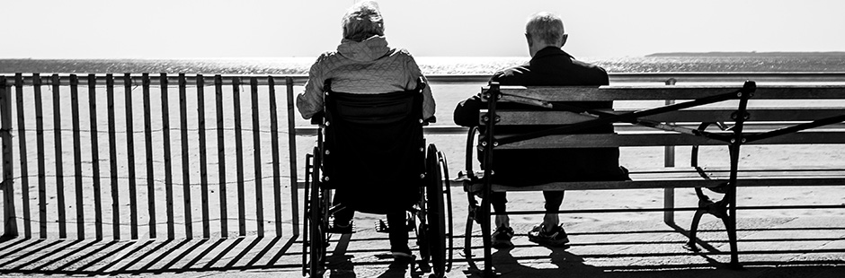

AfriNEAD addressing lack of research about disability in Africa
Author: Corporate Communication and Marketing Division: Daniel Bugan
Published: 01/12/2020
​​The Stellenbosch University (SU) Year for Persons with Disability has culminated in the sixth African Network for Evidence-to- Action in Disability (AfriNEAD) conference, a prestigious international network event that is hosted by SU this week.
The two-day virtual conference, themed “Disability Unplugged: Beyond Charters and Conventions: What really matters to persons with disabilities in Africa", offers keynote speakers, research evidence and roundtable discussions involving academics, governments officials and civil society representatives.
Founded by SU's Centre for Disability and Rehabilitation Studies in the Faculty of Medicine and Health Sciences in 2007, AfriNEAD aims to ensure that networking and research contribute to a better quality of life for people with disabilities in Africa.
Prof Wim de Villiers, Rector and Vice-Chancellor at SU, noted in his welcoming message that AfriNEAD has become a significant facilitator around the needs of people with disabilities on the African continent.
“It has done so by translating disability research into meaningful advocacy, practice, products and policy. And – very importantly – by fostering sound relationships.
“This resonates well with the vision of Stellenbosch University, which directs us to 'advance knowledge in service of society'. To this end, one of our strategic themes is to conduct 'research for impact'. We strive to be relevant to the people of our country, continent and the rest of the world."
De Villiers said 2020 has been declared the Year of Persons with Disabilities at the University, in line with its commitment to inclusivity and promotion of equal opportunities for all.
Prof Jimmy Volmink, Dean of the Faculty of Medicine and Health Science at SU, said the COVID-19 pandemic presents an opportunity to reflect, re-evaluate and reset.
“For people living with disabilities the consequences of the pandemic have been particularly dire. Marginalised as they are in many societies, those with disabilities experience more severe isolation and have greater difficulty gaining access to essential health care and social services. For them the impact of a loss of income is even more profound than that felt by others."
He said AfriNEAD is realising its vision to address the lack of research about disability on the African continent.
“AfriNEAD has succeeded in establishing a dynamic network of stakeholders in Africa and beyond who are actively sharing ideas and evidence. A new open-access journal – the African Journal of Disability – has been formed, making research about disability issues in Africa available. This journal is growing from strength to strength.
“AfriNEAD has also been instrumental in telling the life stories of people with disability. These stories highlight important issues that are fundamental to advancing human rights advocacy and influencing policy."
With reference to the theme of the conference, Volmink said: “The theme draws attention to the many aspirational statements on human rights that exist such as the UN Declaration on Human Rights and the UN Convention on the Rights of Persons with Disabilities. But I think the ultimate intent of the conference is also to challenge us to ask the important questions: How do we go beyond statements of intent to real transformation? And how can persons with disabilities in Africa contribute to this transformation?
“COVID-19 has highlighted the need to build health systems that will provide access to quality care for all. It has emphasised the need to defend the integrity of science, to generate new knowledge and to promote evidence-based decision making. But science and the provision of healthcare alone are not sufficient. We need to advance social justice as this is the key to better health and well-being."

THANK YOU…..

