
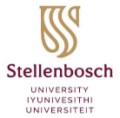

DEPARTMENT OF GLOBAL HEALTH
Advancing global health in Africa and beyond

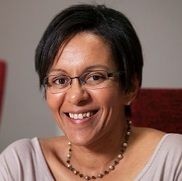
Global Health Webinar Series

Professor Taryn Young, Executive Head, ​​​​Department of Global Health, Stellenbosch University, cordially invites you to a webinar on

Global Inequality and Community Wellbeing:
1 CPD point in Level 1
Positioning Disability Intersectionalities at the Centre of Infrastructures of Social Protection.

17 January 2023, 12:00 – 13:30pm,
Venue: Lecture room 6, 1st Floor (Auditorium), Education Building

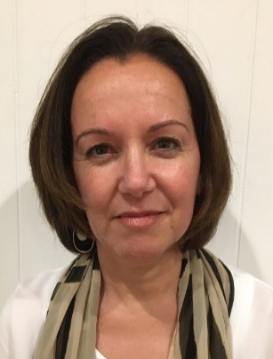
The impacts of Covid-19 have reminded us of the severe disparities in social inequalities that continue to thrive in our world. For so many of our community members, the experience of Covid-19 was one of repetition. First, the experience of the well-established disproportionate inequities in health and social care systems, delivery and distribution, both prevailed and often, became more entrenched for highly marginalised groups, especially for those living with disability, chronic conditions and ill-health. Second, the experience of being invisible to health and social care systems, services and the workforce because of one’s position of marginality were deepened. And third, the absence of social and political representation of our most vulnerable community members in decision making throughout the covid crises, particularly for community members who live at the intersections of racism, classism, ableism and cissexism, was persistent and unrelenting.
Karen Soldatic, PhD (Distinction)
Institute for Culture and Society
School of Social Sciences
Western Sydney University
K.Soldatic@westernsydney.edu.au

This paper will be driven by two core questions that will seek to explore the important role of sociologies of disability in shaping disciplinary understandings within the sociologies of inequality in a post-pandemic world. First, it asks, what role can sociologies of disability play in deepening the epistemological engagement with deepening sociological questions of inequality? Second, it asks, how can we, as sociologists of inequality, engage in co-creating sustainable research practices to broaden out and mobilise civil and political understandings of disability inequity – in both its production and reproduction – to address the deepening structural relations of ableism that are emerging in our pandemic world?

Karen Soldatic is a Professor at the Institute for Culture and Society, School of Social Sciences, Western Sydney University and Whitlam Fellow, Whitlam Institute ​whose work engages with critical questions in relation to global disability inequalities and the impact of the rights of persons with disabilities, particularly minority women with disability. She was awarded a Fogarty Foundation Excellence in Education Fellowship for 2006–2009, a British Academy International Fellowship in 2012, a fellowship at The Centre for Human Rights Education at Curtin University (2011–2012) and an Australian Research Council DECRA Fellowship (2016–2019). Her research on global welfare regimes builds on her 20 years of experience as an international (Cambodia, Sri Lanka, Indonesia), national and state-based senior policy analyst, researcher and practitioner. She obtained her PhD (Distinction) in 2010 from the University of Western Australia and has published extensively in the area in the leading disability studies journals. She now leads the Routledge Interdisciplinary Disability Studies Series.
For queries and rsvp, contact Assoc. Prof Lieketseng Ned on lieketseng@sun.ac.za

